For Immediate Release
Contact:
Nancy Peterson
Florida PLT Coordinator
Phone: 352-846-0848
E-mail: njp@ufl.edu

Rex Lumber Awarded 2015 Business Partner of the Year by Florida Project Learning Tree

Gainesville, Fla. (Dec. 18) – Florida Project Learning Tree awarded Rex Lumber Business Partner of the Year at its annual professional development conference, “Planet Diversity: Trees Gone Wild!” held in Melbourne in November. The award was graciously accepted by Caroline Dauzat, owner, at the Graceville, FL office.
Each year Florida Project Learning Tree recognizes and awards one business partner,that has demonstrated outstanding dedication, support, and service to the program. The nonprofit environmental education program succeeds with the contributions and commitment of business partners who appreciate the importance of Florida PLT.
Since 1926, Rex Lumber has been manufacturing the highest quality Southern Yellow Pine lumber products available, and has worked to become a leader in the softwood lumber industry. Rex Lumber provides premier quality products and service. The company is a fourth generation family owned business, and operates a group of companies, employing over 500 individuals in Florida, Alabama, and Mississippi.
Rex Lumber has been supporting Florida PLT since 2012. Rex Lumber owner, Caroline Dauzat along with the McRae family has provided generous support to Florida PLT. Rex Lumber's contributions have enabled Florida PLT to reach more educators and youth throughout the state.
About Florida Project Learning Tree®
Florida Project Learning Tree is an affiliate of the national environmental education program Project Learning Tree. Florida Project Learning Tree is located within the University of Florida’s School of Forest Resources and Conservation (SFRC) in Gainesville, FL. Florida PLT is one of 50 states, a part of Project Learning Tree’s network of more than 500,000 educators. Throughout the state the program is committed to promoting PLT programs and initiatives. –MORE-
PLT is a versatile, interdisciplinary, environmental education program with an award winning curriculum that engages students in both indoor and outdoor activities. To find out more about Florida Project Learning Tree and its affiliation with the national Project Learning Tree program, as well as its relationship with the University of Florida’s SFRC visit http://www.sfrc.ufl.edu/plt.
###
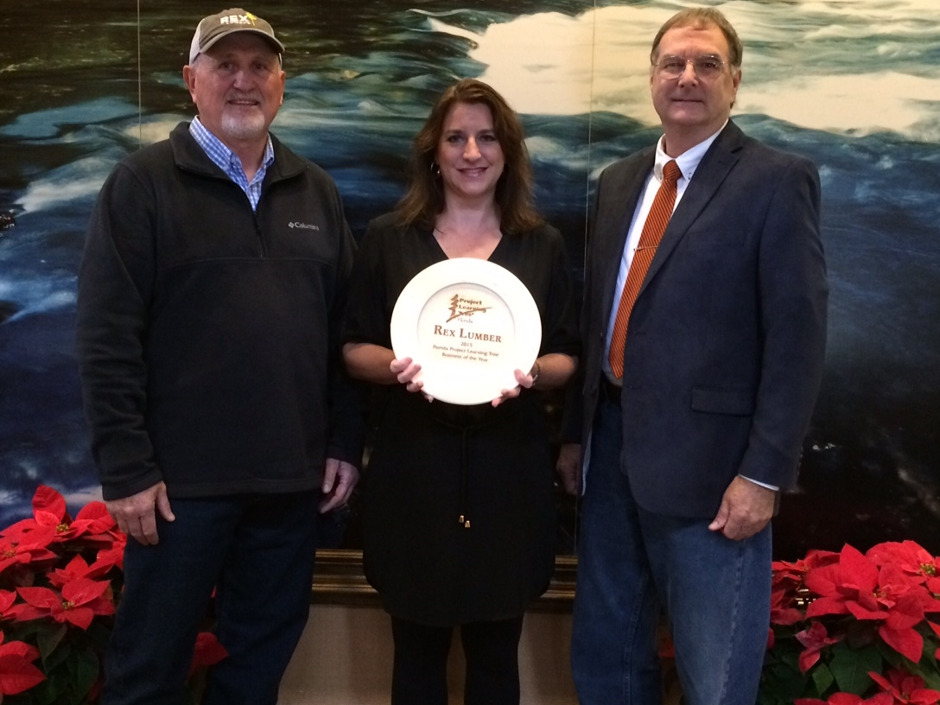
Virgil Shannon (Left) Rex Lumber Wood Procurement Manager, Caroline Dauzat (Center), Rex Lumber owner, and Ed Lewis, Florida PLT Steering Committee member

